Pray for Your President & World Leaders
April 13, 2017
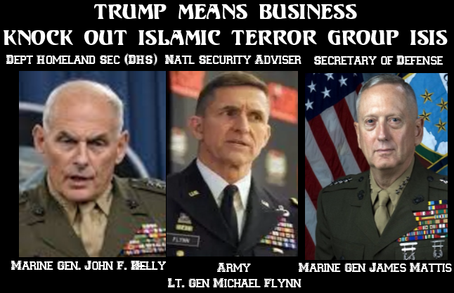
May we be the people of prayer the Lord is counting on in this hour, dear Heartdwellers.

Ezekiel went to open his phone and saw that we had bombed Afghanistan with a huge device…and I didn’t dig any deeper, because He has been discouraging that. Believe me, my curiosity was killing me! But thanks to the Lord’s grace, I still haven’t sought out more news but came directly to Him to find out what was going on.

By the way, President Trump was being criticized of his military intervention in other countries. And that was part of his policy, his platform that he was running on. So, a lot of people are looking at this and doing an about-face for him. And the Lord wanted to clarify what's really going on.

So this is what He said, “Allow Me to put events in perspective. For the last 8 years and even more, you’ve had milk-toast presidents who have caused thousands of their people to be killed in military operations that were doomed from the start. As a result of that, America has had two black eyes and a bloody nose, as well as many broken bones.

"Our military strategy is looked down upon as the world’s worst. President Trump as a private citizen did not have the perspective he has in office now after hours and hours of meetings with military advisors. Hours of briefings, and through those grueling hours he has come to understand that no country on this Earth can remain an island; all are tied together.

"What has been lacking is a strong arm against the enemy. And because of that, our military actions look incompetent in the eyes of the world so that the U.S. would no longer be a nation to be respected. When Donald took office, you were at the door of a world war that would have annihilated America, thanks to the measures taken by the former president and others working nefariously behind the scenes.

"Now that Donald understands the dynamics of military force and a balance of power between the nations, he is having to do an about-face in his policies and seriously amend his thinking to reinstate this country.

"I am still with him, Clare. I have never left his side and I am teaching him how to go about restoring respect for America.

"There are many new courses of action he is setting in place. I will advise him with the best counsel, led by Me. In the meantime, what was meant for disaster is being turned to good, because the world is starting to fear this president who is not afraid to deal with those who are of Satan’s army.

"This is all I can really tell you at this time, Beloved. He is learning and I want all to stand behind him and pray for wisdom. Eventually, good will come from all of this, but for now there is serious fallout and I am enlisting all to pray behind him and the leaders of the world as well as your own congress and senate.

"Pray behind them all that righteousness and wisdom will prevail throughout the world. There are other tests coming and your prayers will forestall much worse scenarios that could damage the U.S. seriously. Pray much for this man and trust that I am still in control. You know from past experiences on the small scale of your life that what the enemy means for evil, I turn to good.

"Well, nothing has changed about My ability to turn things around. All I need are your prayers."

